Computer Networks Experiment
Aim:
To design a simple LAN using hub and configure IP addressing in Cisco Packet Tracer.
Block Diagram:
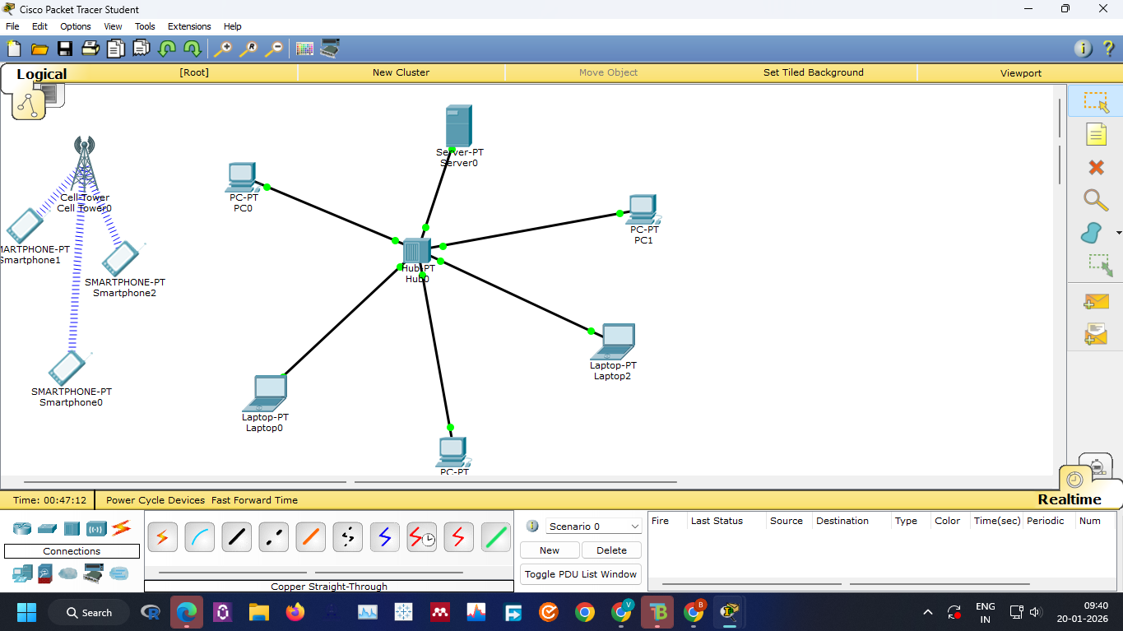
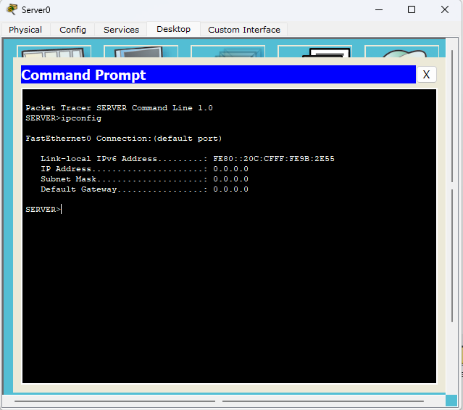
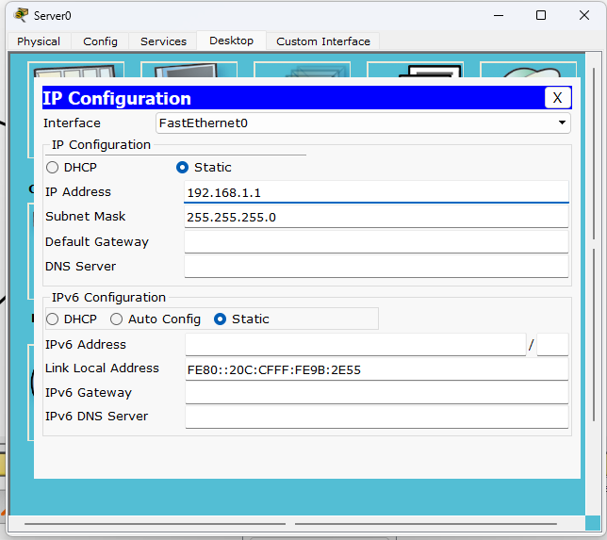

Procedure:
1. Place hub, PCs, laptops and server.
2. Connect using straight-through cables.
3. Configure static IP 192.168.1.1/24 on server.
4. Verify using ipconfig.
Result:
The LAN was successfully created and IP configuration was done.
Output:
Server IP configured as 192.168.1.1 with subnet mask 255.255.255.0.

